


WE

LOCATION:
Chertsey – Samsung HQ

WORKING HOURS:
Monday – Friday 37.5 hours per week

SALARY/DAY RATE/GRADE:
£50,000 - £60,000 per annum

OTHER BENEFITS:
10% Bonus, Life Assurance, Discount portal, Aviva Pension, Samsung Discounts, Company Sick Pay, ETHIC Values - Employee of the month: a chance to win a £500 lifestyle voucher!

CONTACT TYPE:
Permanent

REPORTING IN TO:
Client Service Manager

GRADE / ROLE TYPE
Specialist
DESK-BASED ACCOUNT MANAGER MOBILE B2B SOLUTIONS
WE’RE LOOKING FOR

YOU
NEED

WE’RE LOOKING FOR AN ENGAGING CUSTOMER ACCOUNT MANAGER
As our Desk-Based Account Manager, you’ll provide remote commercial support to Samsung’s B2B customers, focusing on enterprise accounts that do not currently receive face-to-face support.

This role is responsible for identifying opportunities to grow customer accounts, providing guidance on mobile, tablet, computing, and wearable solutions, and sharing roadmap updates. The Account Manager will retain full ownership of every opportunity throughout the complete sales lifecycle, from initial identification and qualification through to commercial close, with no handover to a field sales team.

TO MAKE A REAL DIFFERENCE IN THESE AREAS

CUSTOMER ENGAGEMENT & ACCOUNT SUPPORT
- Provide over-the-phone support to Samsung enterprise customers and partners, helping them get the most from Samsung mobile solutions
- Build and maintain strong relationships with assigned customers
- Share updates and roadmap information about Samsung’s B2B hardware and software portfolio
- Act as a first point of contact for questions related to mobile, tablet, computing, and wearable solutions

OPPORTUNITY IDENTIFICATION, OWNERSHIP & CLOSURE
- Identify, develop, and close sales and business development opportunities across all Samsung mobile solutions
- Own and progress every opportunity from initial customer need and discovery through qualification, solution development, proposal, negotiation, and close
- Work closely with internal specialists and sales teams for support where required, while retaining full commercial ownership and accountability for closing each opportunity

SUPPORT & ENABLEMENT
- Provide guidance remotely to help customers understand Samsung solutions and their benefits
- Assist customers in understanding product capabilities, compatibility, and roadmap updates
- Support Sales and Marketing teams in customer-focused initiatives, events, and remote workshops where appropriate

REPORTING & ADMINISTRATION
- Maintain accurate records of customer interactions, account activities, and opportunities in CRM systems
- Provide regular updates to management on account health, activity, and potential opportunities
- Support internal teams with feedback on customer needs, potential product enhancements, and emerging trends

OUR IDEAL PERSON &
THE ESSENTIALS WE’RE AFTER

- You’re experienced in business, or hold a degree in a business / sales related field
- You’re a strong communicator, with the ability to engage customers over phone and email
- You have professional experience with mobile technologies (Android)
- You’re experienced in working with B2B customers or in account management
- You’re commercial focused, with a good understanding of IT services, mobile solutions, and enterprise processes
- You’re highly organised, proactive, and able to manage multiple accounts independently
- You’re a self-motivated team player with the ability to work collaboratively across internal teams
- You’re ideally knowledgeable of Samsung B2B portfolio, including Knox security solutions
- You’re ideally familiar with Mobile Device Management (MDM), Android Enterprise, or other enterprise mobility platforms
- You’re ideally aware of Android/Wear OS, OS security, or app deployment in enterprise environments
- You have an understanding, and ideally, working knowledge of CRM platforms such as salesforce.com

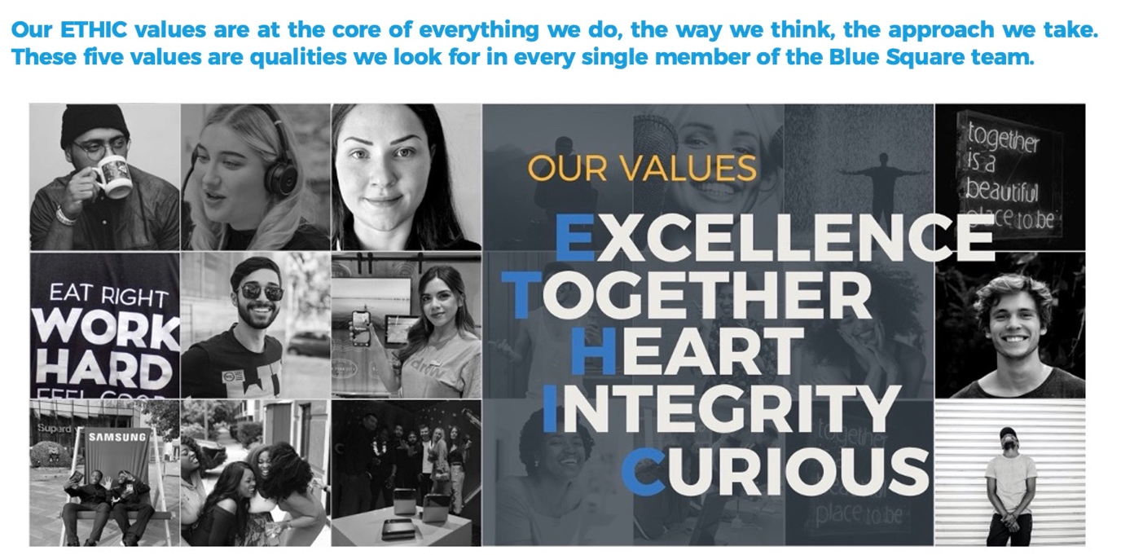
ENTER JOB TITLE HERE

